Ideation Phase
Define the Problem Statements

Date | 07 March 2026
Team ID | Sumit Yadav, Bipin Kole, Sagar Shrikant, Vaishnavi Khot
Project Name | Plugging into the Future: An Exploration of  Electricity Consumption Patterns Using Tableau
Maximum Marks | 2 Marks

Customer Problem Statement Template:
Create a problem statement to understand your customer's point of view. The Customer Problem Statement template helps you focus on what matters to create experiences people will love.
A well-articulated customer problem statement allows you and your team to find the ideal solution for the challenges your customers face. Throughout the process, you’ll also be able to empathize with your customers, which helps you better understand how they perceive your product or service.
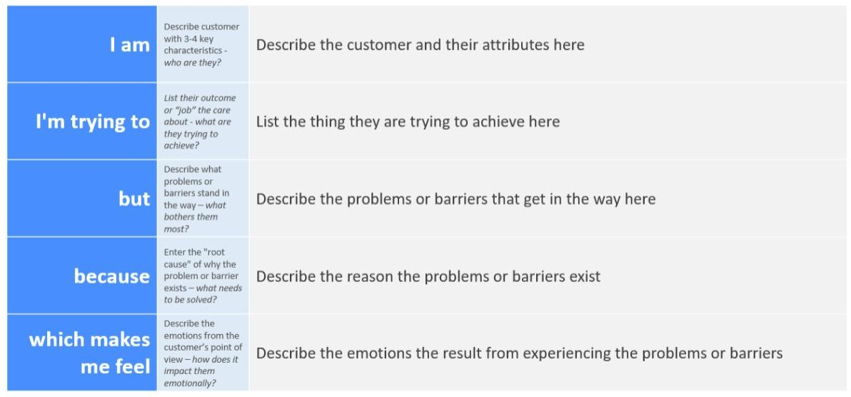
Reference: https://miro.com/templates/customer-problem-statement/ Example:
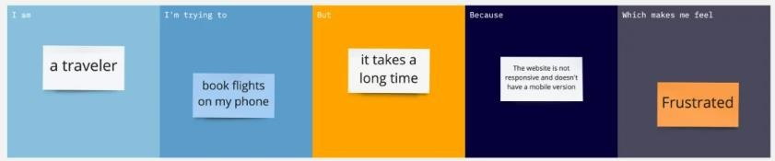
Problem  Statement (PS) | I am  (Customer) | I’m trying to | But | Because | Which makes me feel
PS-1 | I am a traveler | I’m trying to book flights on my phone | But it takes a long time. | Because the app is not responsive and doesn't have a mobile version. | Which makes me feel frustrated.
PS-2 | I am traveler | I’m trying to book flights on my phone | But it takes a long time. | Because the app is not responsive and doesn't have a mobile version. | Which makes me feel frustrated.

